Software Requirement Engineering Lab
Mid Paper



Submitted by: Abdul Samad, Abdul Haseeb, Fasih Ur Rehman, Zain Ali, Haris Azmat
Submitted to: Sir Fahim Muhammad Khan

Semester: V - BSSE (Group-A)
Session 2024 –2028 (Fall)

INSTITUTE OF MANAGEMENT SCIENCES
HAYATABAD, PESHAWAR (2025)

Group Member Names
- Abdul Samad
- Abdul Haseeb
- Fasih Ur Rehman
- Zain Ali
- Haris Azmat

Mid Paper Solution
*-----------------------------------------------*
Question 1:
(a)
Two requirements engineering mistakes
- Incomplete requirements elicitation: The team failed to identify students need to track application status and the admission departments need for document correction.
- Unverified Requirements: The requirements were not properly reviewed with stakeholders to confirm that all the essential features were included before development

(b)
Two stakeholders

- Students applying for the admission
- Admission department staff

(c)
Two problems that Could have been Solved

- Stakeholder interviews : Consult studnets and admission staff to gather their needs, including status tracking and document correction.

- Requirements validation through prototype reviews: Let stakeholders review a prototype and confirm that it supports all essential admission workflows before development

Question 2:
File Available in the uploaded zip/folder.
Question 3:
(a)
- Students: They are the main users of the portal. They can provide requirements about login, examination results and dashboard and other features.
- University Administration: They can provide information about university policies, student records, examination results and portal-related rules
- IT Department: They can provide requirements related to security, system performance, technical issues and the existing portal infrastructure

(b)
- Secure student login Must-be (M): Students expects their accounts and personal information to be protected

- Displaying examination results Must-be (M): Students expects to access their examination results through the portal.

- Fast dashboard loading One-dimensional (O): Faster loading increases user satisfaction, while slow loading causes dissatisfaction

- Personalized course recommendations Attractive (A): It is an extra feature that can make students happy, but its absence may not disappoint them

- Dark mode Indifferent (I): Most students may not consider it an important feature for using the portal.

(c)
Justification
Secure student login is classified as a Must-be requirement because students expect their personal information to be protected. If the portal does not provide secure login, students will be dissatisfied. however having secure login is simply a basic expectation.

Question 4:
a. Selected techniques
- Interviews
- Observation
b. Why each technique is suitable
Interviews: When it's a one by one interview, doctors will be the ones facing scheduling conflicts, and you can ask follow-up questions and learn how doctors' schedules, surgeries, and emergencies really conflict.
Observation: Not all patients will be able to identify the reason for their delayed response. When a person doesn't mention manual data entry or doctors being late when they watch registration, queues and consultations they will see the true causes
c. Interview question for a doctor
If there is a scheduling conflict, for example, two patients scheduled at the same time, or an emergency patient disrupting the schedule, what do you think should happen? When a patient calls, what would you like to have happen instead in the new system?

Question 5:

(a)
Ambiguity: There is subjectivity in the words used, for example “fast”, “user-friendly” and “highly secure”, which are all interpreted differently by each stakeholder.
Not testable: No measurable targets (time, success rate, standard) are given and therefore it is not possible to check if it is met.

(b)
Req 1: The system should complete a fund transfer and display the result within 3 seconds for 95% of the transactions under 1000 concurrent users.
Req 4: All data in transit is encrypted via TLS 1.2 or greater and two factor authentication is required on each and every login.

(c)
c. Structured requirement
Field | Details
ID | FR-003
Description | The system shall allow an authenticated customer to transfer money to another valid account after checking that the balance is sufficient.
Priority | High
Acceptance Criteria | (1) A valid transfer debits the sender, credits the beneficiary, and shows a confirmation with a transaction reference number. (2) If the balance is insufficient, the transfer is rejected with an error message and no money moves.

Question 6:
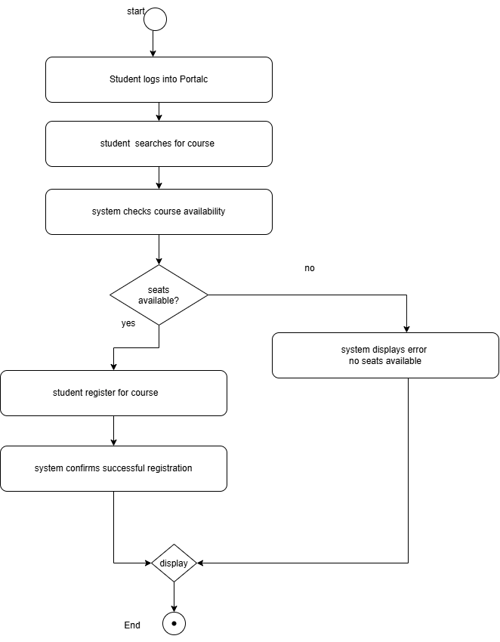

*-----------------------------------------------*
The End

